Nội dung file : base.html
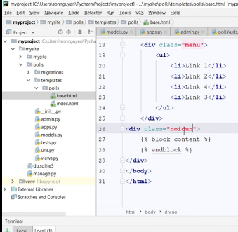
Nội dung file index.html
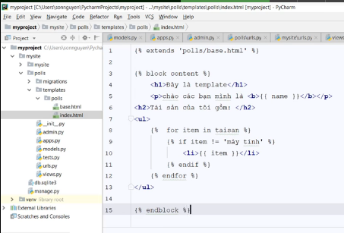
Nội dung : views.py
from django.http import HttpResponse
from django.shortcuts import render
def index(request):
myname = "Ngoc Than"
taisan =("Dienthoai","may tinh","may bay")
context =("name":myname,"item":taisan)
return render(request,"polls/index.html",context)

